**(rock, paper, scissors) Game Using Micro:bit**

**1 - What is micro:bit ? :**is a small, programmable computer designed to help students learn about technology, coding, and electronics.

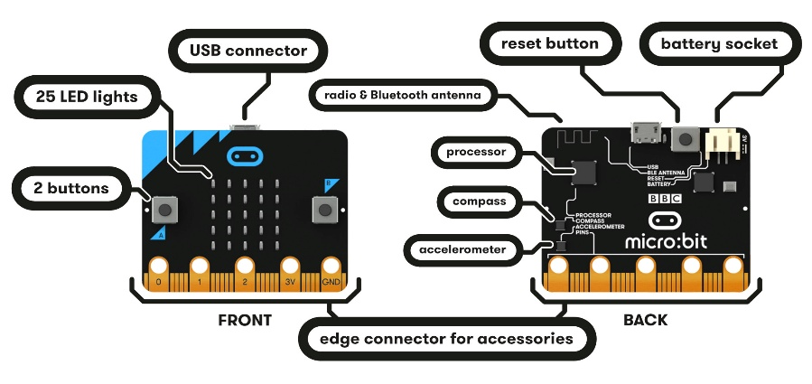**2 - Micro: Bit Components:**

**Front Side:**

* LED Display (5x5 Grid):

A grid of 25 small LED lights that can show numbers, letters, shapes, and even simple animations. You can program it to display images, text as shown below:

* Buttons (A and B):

Two programmable buttons (A and B) that can be used for interacting with the micro:bit, such as controlling games or triggering actions in your program.

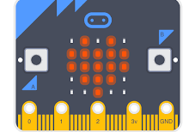

* USB Connector:

A micro-USB port that is used to power the micro:bit and to transfer programs (code) from your computer to the micro:bit.

* Edge Connector for Accessories:

The golden strip at the bottom has 25 pins. These can be connected to external components like sensors, motors, or LEDs, making the micro:bit highly customizable for projects.

**Back Side:**

* Radio & Bluetooth Antenna:

Allows the micro:bit to wirelessly communicate with other devices, including other micro:bits or smartphones, using radio signals or Bluetooth.

* Reset Button:

A small button to restart the micro:bit. This is useful if you want to run your program from the beginning or troubleshoot.

* Battery Socket:

A slot for attaching an external battery pack to power the micro:bit when not connected to a computer.

* Processor:

The (brain) of the micro:bit that runs the code you upload. It processes all inputs and controls the outputs.

* Compass:

A sensor that detects the Earth's magnetic field, allowing the micro:bit to function as a digital compass or detect nearby magnets.

* Accelerometer:

A sensor that detects motion and orientation. It can tell if the micro:bit is being shaken, tilted, or moved, which is great for motion-sensitive projects.

**3- Components Quiz:**

**Kahoot Quiz**

**4 – How Can We Program The Micro:Bit?**

There are two ways to program the Micro:Bit:

* + By programing Languages:

Python or JavaScript



* + Programing Blocks (Drag and Drop Commands):

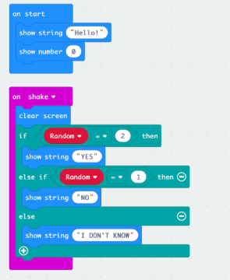

**5 – Programing Blocks (Drag and Drop Commands):**

Now let we go through how to make (Rock Paper Scissors) Game as your first project by using Programing Blocks

* **Step 1 :**

**Search for MakerCode Editor in google :**[**https://makecode.microbit.org/#editor**](https://makecode.microbit.org/#editor)

* **Step 2 :**

**Click on new project and name it : Rock – Paper – Scissors**

**Then this screen will appear**

* **Step 3 :**

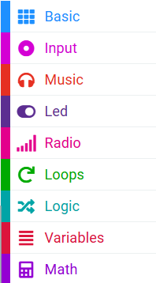We just will use this command Groups:  
   
From :

We need 3 of

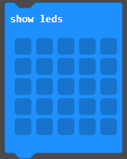



From :

We need 3 of

  
From :

We need :



**AND**

From :

Go to click on button and name a variable “Random_Number“ or “RandNum” For Short then click **OK**

These Blocks will appear:

**Blocks that we need**



From :

Scroll down until you find **(Pick Random)** Block



Set the range of numbers From 1 to 3

**This should be looks like when we finished :**

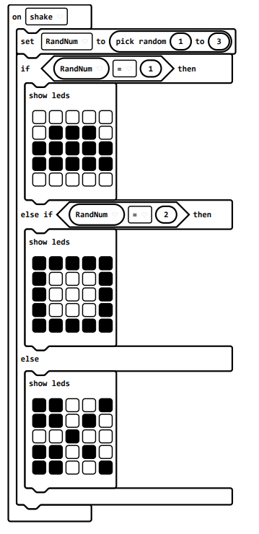

**6 -** **Programing Blocks (Drag and Drop Commands) Quiz:**

**Kahoot Quiz**

**7 – Your turn to make (Rock – Paper - Scissors) Game:**

Now students should make the project in 20 minutes as a competition